# Week 12 Homework:

1. Using the methods learned earlier in this curriculum, create the following Assembly Drawing Sheet:

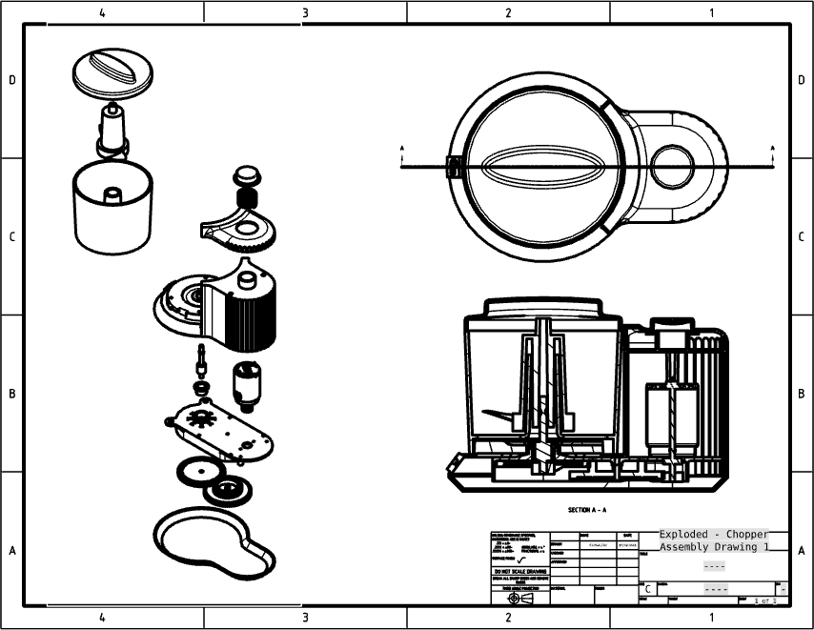

1. Add the appropriate hardware (screws, nuts, bolts) to the Mini Chopper, utilizing the measure tool and the section tool to determine the proper size & length of the screws, nuts and washers.
2. Apply materials and record the Mass Properties on the Assembly Drawing.
3. Use the Measure tool to determine the clearance between the blade tip and the inside of the bowl.